Vignesh Thiagarajan – Assignment 2

Junit Testcases - Passed

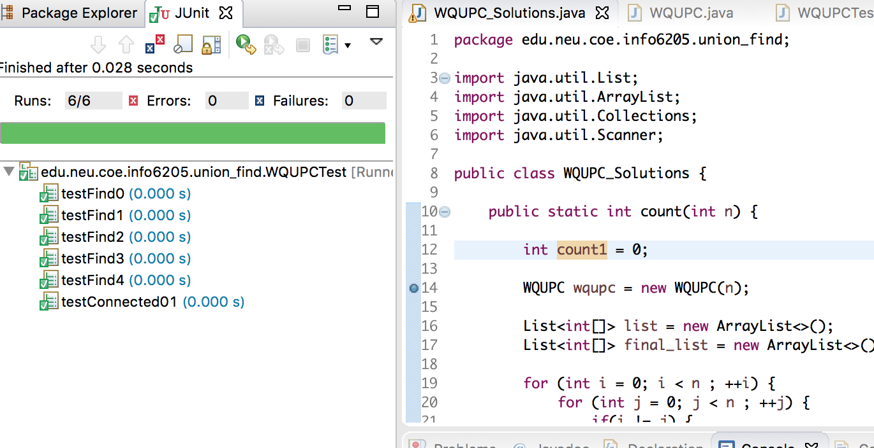

Hypothesis

Number of pairs generated ~ ½ N ln(N)

Where in N is the number of sites.

For N = 10,

As per the algorithm, randomly generated pairs -

pairs used for union:

(1 5)

(8 7)

(2 1)

(8 5)

(8 6)

(9 0)

(5 3)

(9 4)

(9 7)

number of randomly generated pairs is 9

The minimum number of pairs for which we need to get a single component is N -1

